## Visvesvaraya Technological University Belagavi-590018, Karnataka



##### A Mini Project Report on

**“DTH DATABASE MANAGEMENT SYSTEM”**

**Submitted in partial fulfillment of the requirement for the Database Applications Lab [Subject Code]**

**Bachelor of Engineering**

**in**

**Information Science and Engineering**

**Submitted by**

**Trupthi [1JT18IS061]**

**Priyanka P[1JT18IS048]**

**Department of Information Science and Engineering Jyothy Institute of Technology**

**Tataguni, Bengaluru-560082**

**Jyothy Institute of Technology**

**Tataguni, Bengaluru-560082**

**Department of Information Science and Engineering**



**CERTIFICATE**

###### Certified that the mini project work entitled **“DTH DATABASE MANAGEMENT SYSTEM”** carried out by **Trupthi [1JT18IS061], Priyanka P [1JT18IS048]** bonafide student of Jyothy Institute of Technology, in partial fulfillment for the award of **Bachelor of Engineering** in **Information Science and Engineering** department of the **Visvesvaraya Technological University, Belagavi** during the year **2019-2020**. It is certified that all corrections/suggestions indicated for Internal Assessment have been incorporated in the Report deposited in the departmental library. The mini project report has been approved as it satisfies the academic requirements in respect of Mini Project work prescribed for the said Degree.

Guide, .Professor Guide,Asst.Professor Professor and HOD Dept. Of ISE Dept. Of ISE Dept. Of ISE

External Viva Examiner Signature with Date : 1.

2.

## ACKNOWLEDGEMENT

Firstly, we are very grateful to this esteemed institution **“Jyothy Institute of Technology**” for providing us an opportunity to complete our project.

We express our sincere thanks to our Principal **Dr. Gopalakrishna K for** providing us with adequate facilities to undertake this project.

We would like to thank **Dr. Harshwardhan Tiwari, Professor and Head** of Information Science and Engineering Department for providing for his valuable support.

We would like to thank our guides **Ms. Kalpitha N, Asst. Prof.** for her keen interest and guidance in preparing this work.

Finally, we would thank all our friends who have helped us directly or indirectly in this project.

**Trupthi [1JT18IS061]**

**Priyanka Prashanth Kumar [1JT18IS048]**

## ABSTRACT

In this mini project we have created an application which is easy to access and user friendly. For this application we used the back-end as SQL to store the data which is used in the application and for the user interface, we have used JAVA. The users are able to access this application. The purpose of this application is for smooth streaming and to get a brief idea of overall working and methodology of DTH services. The application keeps a backup of the DTH data which includes the admin details, customer details, set-top box details and the packages they offer.

The use of DTH service is rapidly increasing in India and other countries; the manual maintenance DTH connection information by admin is very strenuous and also consumes a lot of time. For this reason, an efficient system is to be proposed to ease the issue of DTH management system. The proposed system is a desktop - based application that allows admin to manage setup box, package, customer and payment details.

.

|  |  |  |
| --- | --- | --- |
| **SL No** | **Description** | **Page No.** |
| 1 | INTRODUCTION | 6 |
| 2 | DESIGN | 9 |
| 3 | IMPLEMENTATION | 12 |
| 4 | RESULTS AND SNAPSHOTS | 17 |
| 5 | CONCLUSION | 30 |

TABLE OF CONTENTS

***CHAPTER 1 INTRODUCTION***

### INTRODUCTION

#### Introduction to DBMS

A database is simply an organized collection of related data, typically stored on disk, and accessible by possibly many concurrent users. Databases are generally separated into application areas. For example, one database may contain Human Resource (employee and payroll) data; another may contain sales data; another may contain accounting data; and so on. Databases are managed by a DBMS.

The choice of a database product is often influenced by factors such as: the computing platform (i.e., hardware, operating system)

* the volume of data to be managed
* the number of transactions required per second
* existing applications or interfaces that an organization may have
* support for heterogeneous and/or distributed computing
* cost
* vendor support

#### Introduction to SQL

[**SQL**](https://en.wikipedia.org/wiki/SQL), which is an abbreviation for **Structured Query Language**, is a language to request data from a database, to add, update, or remove data within a database, or to manipulate the metadata of the database.

SQL is a declarative language in which the expected result or operation is given without the specific details about how to accomplish the task. The steps required to execute SQL statements are handled transparently by the SQL database. Sometimes SQL is characterized as non*-*procedural because procedural languages generally require the details of the operations to be specified, such as opening and closing tables, loading and searching indexes, or flushing buffers and writing data to filesystems. Therefore, SQL is considered to be designed at a higher conceptual level of operation than procedural languages because the lower level logical and physical operations aren't specified and are determined by the SQL engine or server process that executes it.

#### Introduction to Zoo Management Database

The world in the 21st century is growing up in the technology in every field such as education, medicine, transport etc. The use of technology makes the world so faster and easier than the early world and it releases the world from manual usage in the every field.

In the early days, the manual usage causes many mistakes by the user and administrative. Using manual properties in the fields was not comfortable for the consumers because it was slower than technical usages, caused wastages of the consumers’ time and contained many formalities in usage.

This project of using technology in DTH fields for administration, maintenances, staff details, and donation fields. Now also most of the zoological parks are using manual programs in their administration, maintenances, staff details entry and ticketing fields. This project was prepared for using computerized programs for the above fields. According to the basic needs of programs for this zoological park, this project was prepared to make the works easier.

#### Scope and importance of work

The scope of the project is clear to give a simple and attractive application to simplify the work as well as to reduce the efforts while doing it offline or we can say by doing it with old methods.

In this application we are able to save the database of all the staff, animals need, tourist data and donation details.

The staff data includes the staff profession and their salary details, the animal data includes the type of animal (either herbivore or carnivore) and their feed cost, tourist data includes the ticket details and the donations table includes visit fare, amount taken by respective manager.

# CHAPTER 2 DESIGN

Theory of ER Diagram

An **entity relationship diagram** (**ERD**) shows the relationships of entity sets stored in a database. ... By defining the entities, their attributes, and showing the relationships between them, an **ER diagram** illustrates the logical structure of databases. **ER diagrams** are used to sketch out the design of a database.

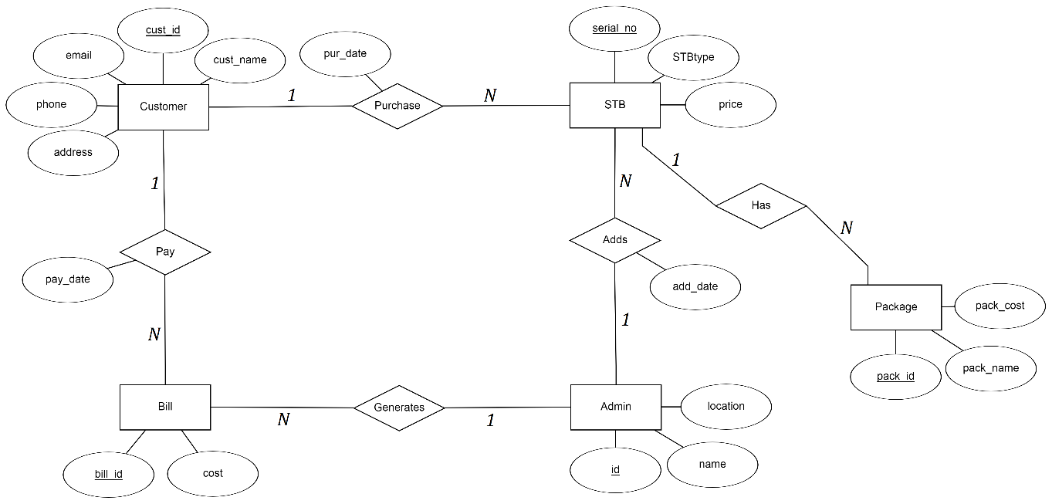ER Diagram

Schema Diagram Activity Diagram

List of Tables

###### <ExAnimals>

* + 1. Animals Classification
    2. Staff
    3. Tourits
    4. Donation

***CHAPTER 3 IMPLEMENTATION***

**Create tables commands, Insert , DESC of tables**

create table STAFF( S_ID varchar(20) primary Key, NAME varchar(20),

OCCUPATION varchar(20), SALARY varchar(10), CITY varchar(20));

create table ANIMALS(A_ID varchar(10) primary Key, SPECIES varchar(30),

AGE varchar(10), FEED_COST varchar(10), KEEPER_ID varchar(20),

foreign Key(KEEPER_ID) references STAFF(S_ID));

create table CLASSIFICATION(A_ID varchar(10), ANIMAL_GROUP varchar(20),

ANIMAL_CLASS varchar(20),

foreign Key(A_ID) references ANIMALS(A_ID));

create table TOURISTS(T_ID varchar(10) primary Key, VISIT_FARE varchar(10),

DATE date, GUIDE_ID varchar(20), GUIDE_FEE varchar(10),

foreign key(GUIDE_ID) references STAFF(S_ID));

create table DONATION(RECEPT_NO varchar(10) primary Key,T_ID varchar(20),AMOUNT varchar(10),MANAGER_ID varchar(20),

foreign Key(T_ID) references TOURISTS(T_ID),

foreign Key(MANAGER_ID) references STAFF(S_ID));

###### Insertion of staff table

Insert into STAFF values('M01','Nagesh','Manager','40000','Bangalore'); Insert into STAFF values('M02','Ramesh','Manager','80000','Belagavi'); Insert into STAFF values('M03','Radha','Manager','450000','Bangalore'); Insert into STAFF values('M04','Mahesh','Manager','78000','Tumkur');

Insert into STAFF values('M05','Akhil kumar','Manager','55000','Bellary'); Insert into STAFF values('G01','Rahul gowda','Guide','35000','Bangalore'); Insert into STAFF values('G02','Raja','Guide','25000','Bangalore');

Insert into STAFF values('G03','Asha','Guide','30000','Bellary');

Insert into STAFF values('G04','Akshay','Guide','28000','Shimoga'); Insert into STAFF values('G05','Jeeva','Guide','25000','Tumkur');

Insert into STAFF values('K01','Anil','Animal keeper','30000','Mangaluru');

Insert into STAFF values('K02','Ajay raj','Animal keeper','32000','Bangalore'); Insert into STAFF values('K03','Bhaskar','Animal keeper','320000','Kalburgi'); Insert into STAFF values('K04','John','Animal keeper','280000','Mangalore');

Insert into STAFF values('K05','Latha','Animal keeper','30000','Mysore');

Insert into STAFF values('K06','Abhishek','Animal keeper','33000','Bangalore'); Insert into STAFF values('K07','Mamatha','Animal keeper','30000','Tumku');

Insert into STAFF values('K08','Kiran','Animal keeper','32000','Mandya'); Insert into STAFF values('S01','Ravi kiran','Security','20000','Mangaluru'); Insert into STAFF values('S02','Mohan','Security','18000','Davangere');

Insert into STAFF values('S03','Sanjay','Security','22000','Kalburgi');

Insert into STAFF values('S04','Prashanth','Security','20000','Sringeri'); Insert into STAFF values('S05','Ramu','Security','22000','Bangalore');

Insert into STAFF values('C01','Ravi','Cleaner','10000','Mysore');

Insert into STAFF values('C02','Aslam pasha','Cleaner','12000','Banagalore'); Insert into STAFF values('C03','Sandhya','Cleaner','11000','shimoga');

Insert into STAFF values('C04','Rajesh','Cleaner','10000','Davangere'); Insert into STAFF values('C05','','Cleaner','12000','Bangalore');

###### Insertion of animals table

Insert into ANIMALS values('AN001','Tiger','15','6000','K05');

Insert into ANIMALS values('AN002','Elephant','50','2000','K02'); Insert into ANIMALS values('AN003','Bear','35','5000','K05');

Insert into ANIMALS values('AN004','Camel','40','2500','K01'); Insert into ANIMALS values('AN005','Cobra','18','2500','K07');

Insert into ANIMALS values('AN006','Crocodile','33','3500','K05');

Insert into ANIMALS values('AN007','Gaint Tortoise','120','1000','K04'); Insert into ANIMALS values('AN008','Gorilla','10','2000','K05');

Insert into ANIMALS values('AN009','Hippopotamus','35','2200','K02'); Insert into ANIMALS values('AN010','Kangaroo','5','4000','K01');

Insert into ANIMALS values('AN011','Leapord','13','5000','K05'); Insert into ANIMALS values('AN012','Parrot','30','1000','K03');

Insert into ANIMALS values('AN013','Rat snake','15','2000','K07'); Insert into ANIMALS values('AN014','Wolf','08','3000','K05');

Insert into ANIMALS values('AN015','Zebra','13','3000','K02');

Insert into ANIMALS values('AN016','African grey parrot','40','1500','K03');

Insert into ANIMALS values('AN017','Deer','15','2000','K04');

Insert into ANIMALS values('AN018','Peacock','15','1000','K03'); Insert into ANIMALS values('AN019','Alligator','15','1000','K03'); Insert into ANIMALS values('AN020','Rabbit','3','1000','K08');

Insert into ANIMALS values('AN021','Gaboon viper','11','3200','K06'); Insert into ANIMALS values('AN022','Fox','13','3200','K08');

Insert into ANIMALS values('AN023','Crane','18','1000','K03');

Insert into ANIMALS values('AN024','white peacock','5','1500','K03');

Insert into ANIMALS values('AN025','Python molurus','5','3500','K06');

###### Insertion of classification table

Insert into CLASSIFICATION values('AN001','Carnivore','Mammal'); Insert into CLASSIFICATION values('AN002','Herbivores','Mammal'); Insert into CLASSIFICATION values('AN003','Carnivore','Mammals'); Insert into CLASSIFICATION values('AN004','Herbivore','Mammal'); Insert into CLASSIFICATION values('AN005','Carnivore','Reptile');

Insert into CLASSIFICATION values('AN006','Carnivore','Reptile'); Insert into CLASSIFICATION values('AN007','Herbivore','Reptile');

Insert into CLASSIFICATION values('AN008','Herbivore','Mammal'); Insert into CLASSIFICATION values('AN009','Herbivore','Mammal'); Insert into CLASSIFICATION values('AN010','Herbivore','Mammal'); Insert into CLASSIFICATION values('AN011','Carnivore','Mammal'); Insert into CLASSIFICATION values('AN012','Omnivorous','Aves');

Insert into CLASSIFICATION values('AN013','Carnivore','Reptile');

Insert into CLASSIFICATION values('AN014','Carnivore','Mammal'); Insert into CLASSIFICATION values('AN015','Herbivore','Mammal'); Insert into CLASSIFICATION values('AN016','Herbivore','Aves');

Insert into CLASSIFICATION values('AN017','Herbivore','Mammal'); Insert into CLASSIFICATION values('AN018','Herbivore','Mammal'); Insert into CLASSIFICATION values('AN019','Carnivore','Reptile');

Insert into CLASSIFICATION values('AN020','Herbivore','Mammal'); Insert into CLASSIFICATION values('AN021','Carnivore','Reptile');

Insert into CLASSIFICATION values('AN022','Omnivorous','Mammal'); Insert into CLASSIFICATION values('AN023','Omnivorous','Aves');

Insert into CLASSIFICATION values('AN024','Omnivorous','Aves'); Insert into CLASSIFICATION values('AN025','Carnivore','Reptile');

###### Insertion of tourist table

Insert into TOURISTS values('T01','1400','2017-06-02','G02','400'); Insert into TOURISTS values('T02','600','2017-06-04','G02','300');

Insert into TOURISTS values('T03','500','2017-06-05','G03','200'); Insert into TOURISTS values('T04','1250','2017-06-08','G01','400'); Insert into TOURISTS values('T05','350','2017-06-11','G01','200');

Insert into TOURISTS values('T06','750','2017-06-14','G01','300');

Insert into TOURISTS values('T07','800','2017-06-15','G05','300'); Insert into TOURISTS values('T08','1000','2017-06-19','G05','400'); Insert into TOURISTS values('T09','950','2017-06-21','G04','300');

Insert into TOURISTS values('T10','1500','2017-06-23','G05','500'); Insert into TOURISTS values('T11','1400','2017-06-24','G01','400'); Insert into TOURISTS values('T12','600','2017-06-26','G02','300');

Insert into TOURISTS values('T13','750','2017-06-26','G03','300'); Insert into TOURISTS values('T14','2000','2017-06-28','G04','500'); Insert into TOURISTS values('T15','800','2017-06-20','G02','300');

###### Insertion of donation table

Insert into DONATION values('R001','T02','2000','M01'); Insert into DONATION values('R002','T03','8000','M01'); Insert into DONATION values('R003','T04','10000','M01'); Insert into DONATION values('R004','T06','2000','M03'); Insert into DONATION values('R005','T07','60000','M02'); Insert into DONATION values('R006','T08','25000','M02'); Insert into DONATION values('R007','T10','15000','M04'); Insert into DONATION values('R008','T12','5000','M05'); Insert into DONATION values('R009','T14','30000','M05'); Insert into DONATION values('R010','T15','35000','M05');

# CHAPTER 4 RESULTS AND SNAPSHOTS

**Select * from Tables, Queries snapshots, Front end snapshots**

###### LOGIN FORM: (left align)

Put figure name and number.

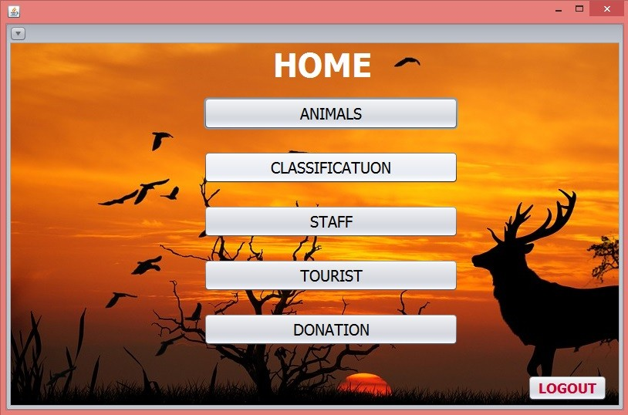HOME PAGE:

ANIMALS PAGE:

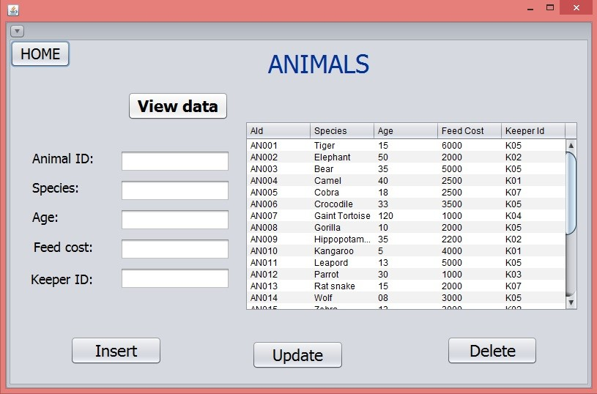

**Figure 3.4 Animal table information**

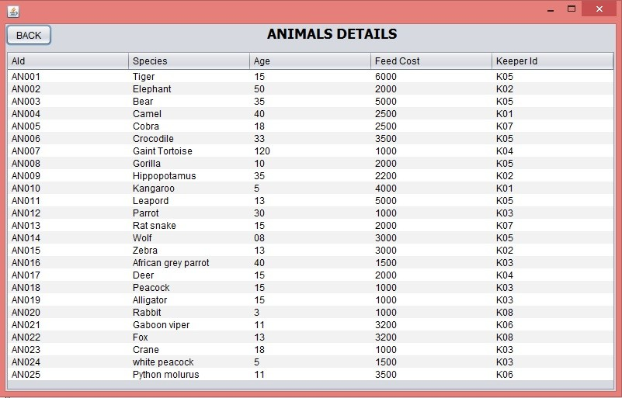

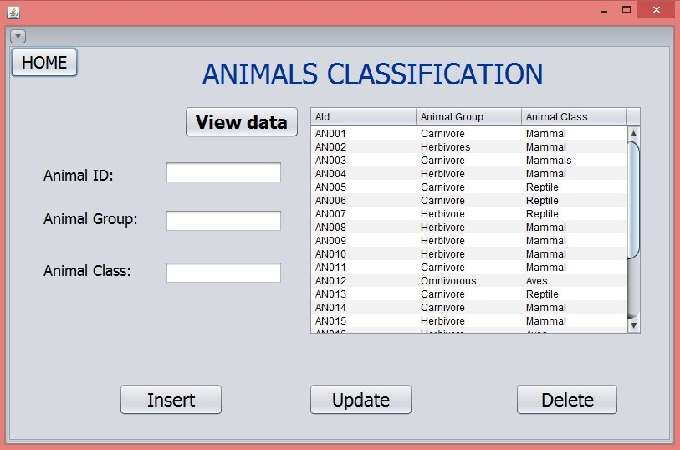

CLASSIFICATION PAGE:

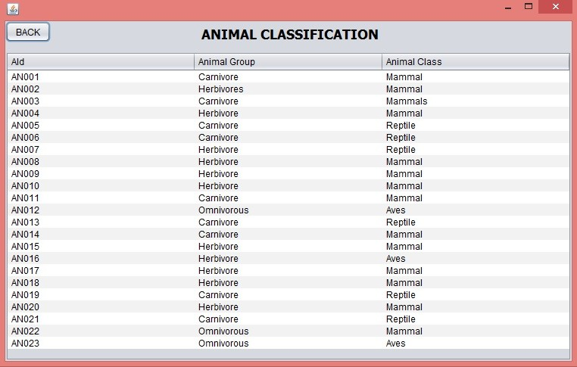

STAFF PAGE:

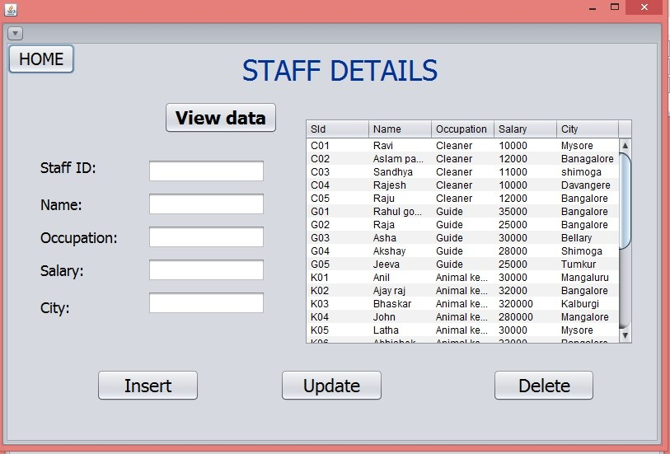

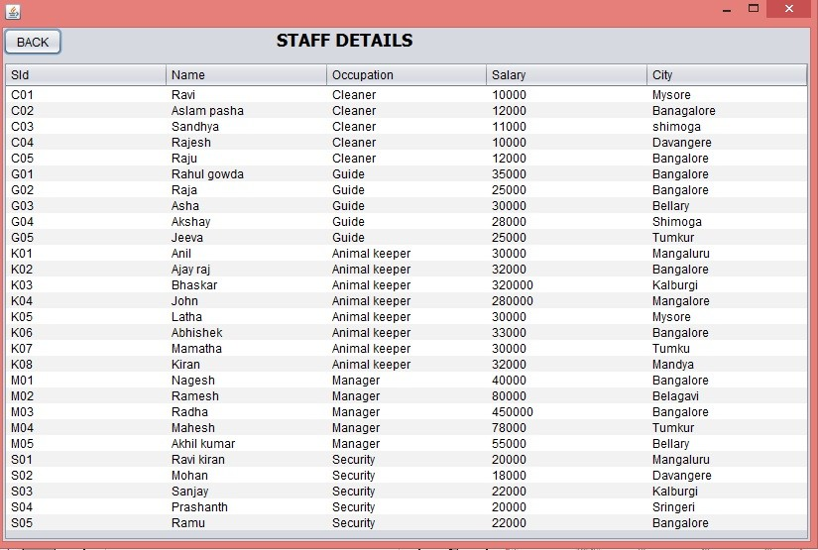

TOURISTS PAGE:

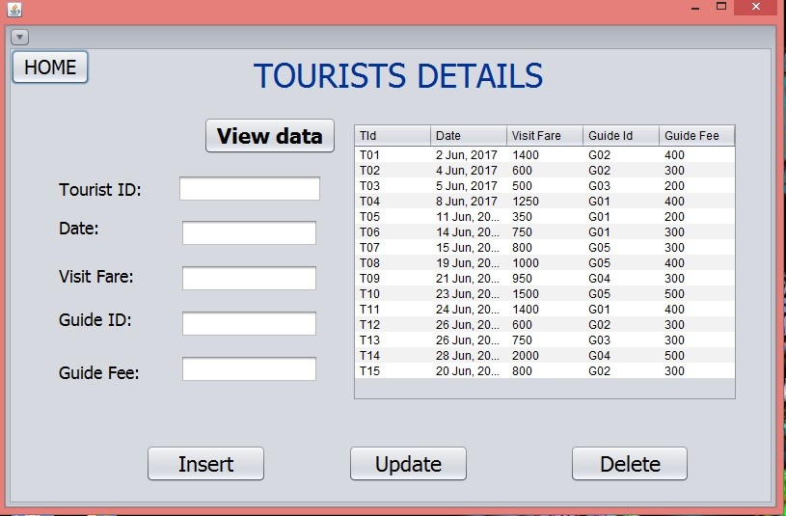

|  |  |  |  |  |  |
| --- | --- | --- | --- | --- | --- |
|  | | | | | |
| TOURIST DETAILS | | | | | |
|  | Tld | Date | Visit Far+ | Guide Id | Guide Fee |
|  | T01 | 2 Jun, 2017 | 1400 | C02 | 400 |
| T02 | 4 Jun, 2017 | 600 | G02 | 300 |
| T03 | 5 Jun, 2017 | 500 | G03 | 200 |
| T04 | 8 Jun, 2017 | 1250 | G01 | 400 |
| T05 | 11 Jun, 2017 | 350 | C01 | 200 |
| T06 | 14 Jun, 2017 | T50 | G01 | 300 |
| T07 | 15 Jun, 2017 | 800 | G05 | 300 |
| T08 | 19 Jun, 2017 | 1000 | G05 | 400 |
| T09 | 21 Jun, 2017 | 950 | C04 | 300 |
| T10 | 23 Jun, 2017 | 1500 | G05 | 500 |
| T11 | 24 Jun, 2017 | 1400 | G01 | 400 |
| T12 | 26 Jun, 2017 | 600 | G02 | 300 |
| T13 | 26 Jun, 2017 | T50 | G03 | 300 |
| T14 | 28 Jun, 2017 | 2000 | C04 | 500 |
| TU | 20 Jun, 2017 | 800 | G02 | 300 |

DONATION PAGE:

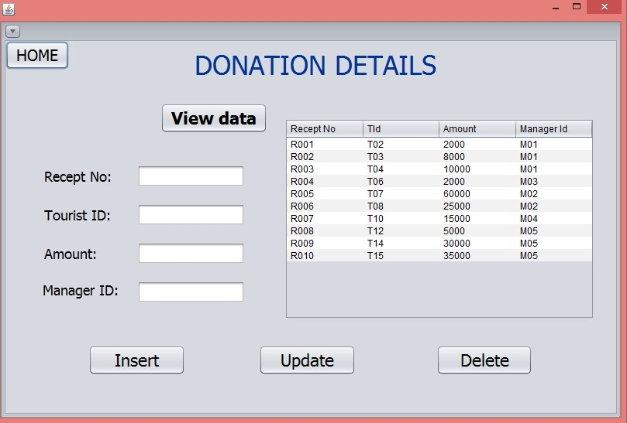

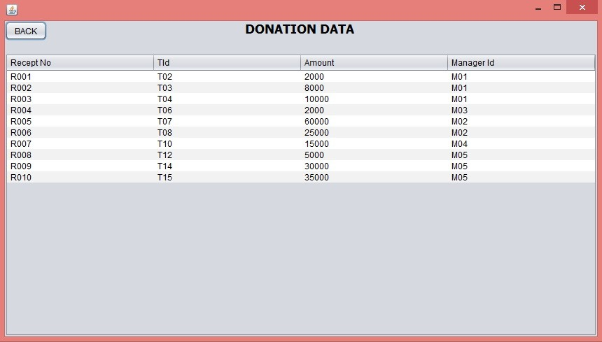

**/ Queries to be added/**

**Conclusion**

Features:

**References:**